**Lab Assignment No 3:** Consider the relational schema given below

Actor (aid, aname, age, salary)

Movie (mid, title, budget)

Plays (aid, mid)

Now give an expression in SQL for each of the following questions.

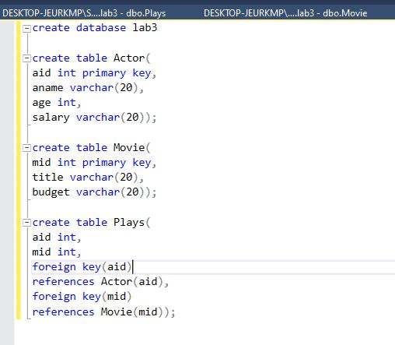

Table for Actor:

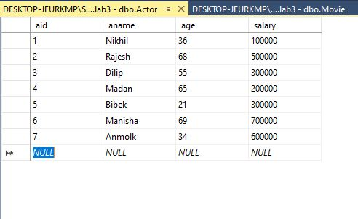

Table for Movie:

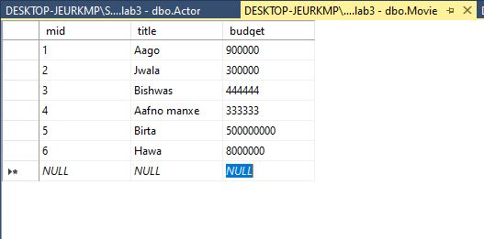

Table for Plays:

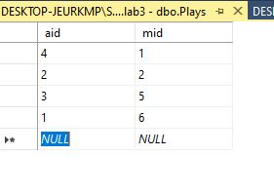

1. Find the name of the youngest actor.

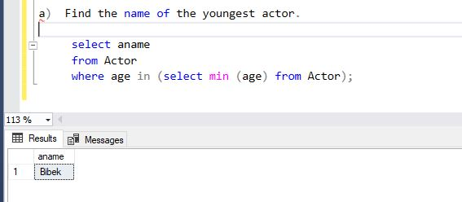

1. Remove those actors who have not played any movies.

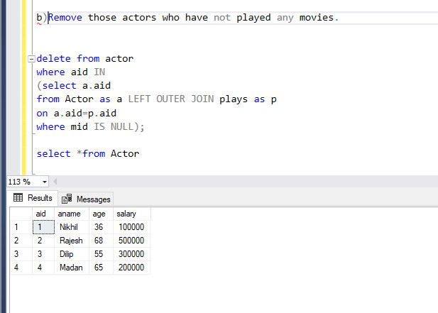

1. Modify the database such that the title of the movie is now changed to ‘Hello Sarkar’ played by Madan Shrestha.

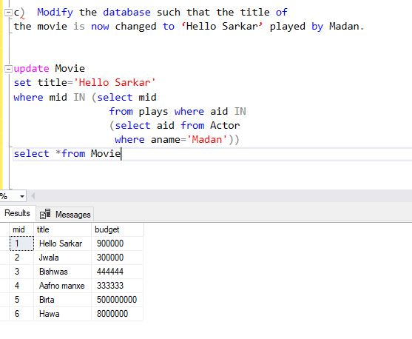

1. Display the name of those actors whose name start with the character “A” and contains exactly 6 characters.

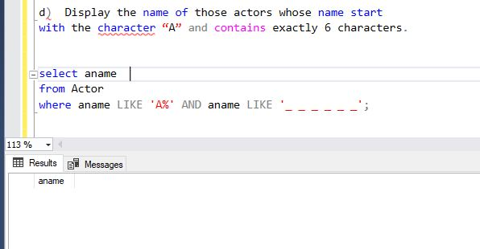

1. Extract the name of the actors who played movies of budget above 8000000.

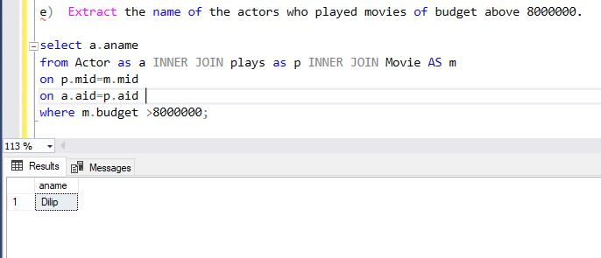

1. Insert new record in the relation ‘Actor’.

